# 2019 PartyMix mapping for VDJ with 2x shifts and Filter - v0.7.0 - DJ Estrela

<https://maps.djtechtools.com/mappings/9764>

Summary:

* This is a 2019 mapping for the numark PartyMix for VirtualDJ. Main feature is two shifts that adds more functions than the available buttons. In particular this makes 12x pads instead of 4x.
* Other features are a Filter, Loop roll mode, FX control of echo+Grid and a pad Index page

Installation:

* Official VDJ installation instructions: <https://www.virtualdj.com/manuals/hardware/numark/partymix/>
* To install this mapping, please decompress the inner zip and copy the contents to your documents/VDJ folder

Overview:

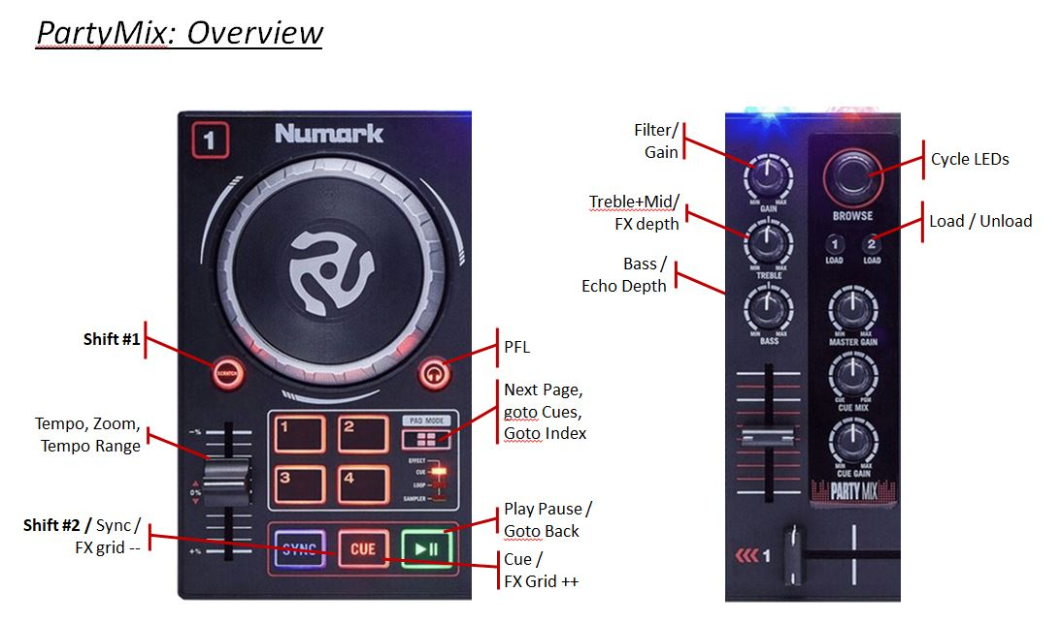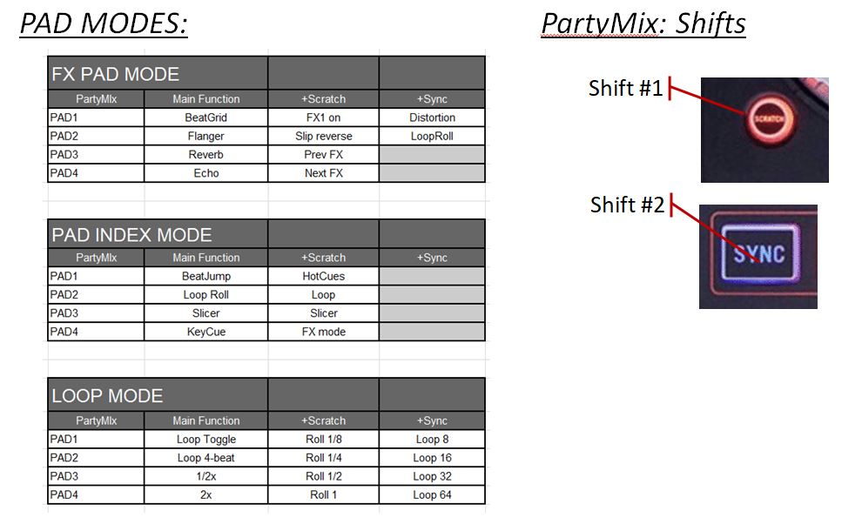

Detailed reference:

|  |  |  |  |
| --- | --- | --- | --- |
|  |  |  |  |
| PartyMIx | Main Function | +Scratch | +Sync |
| SCRATCH | *Shift #1* |  |  |
| SYNC | *Shift #2* |  |  |
|  |  |  |  |
| GAIN | Filter | Gain | Filter Off |
| TREBLE | Treble+Mid | FX Depth |  |
| BASS | Bass | Echo Depth #1 | Echo depth #2 |
|  |  |  |  |
| PAD MODE | Goto Cues page | Goto Pad Index | Next PadPage |
| PAD 1..4 | Pad 1..4 | Pad 5..8 | Shift + Pad 1..4 |
|  |  |  |  |
| SYNC | Sync | FX Grid ++ |  |
| CUE | Cue | FX Grid -- |  |
| PLAY | Play/Pause | Goto Back |  |
| PITCH | Tempo | Zoom | Tempo Range |
| JOG | Scratch | Search |  |
|  |  |  |  |
| BROWSE | Browse | Cycle LEDs |  |
| LOAD | Load | UnLoad |  |
|  |  |  |  |